**Bootstrapping $1,000,000+ for the Angel Vault with Rari Capital (pt. II)**

We continue to search for the best way to create more liquidity for Giveth. In our first proposal, we suggested raising min. $500,000 USD by partnering with DAOHaus and then launching ICHI Angel Vault which would create a buy wall on Univ3 protecting the $GIV price while earning trading fees for the project.

The reward we proposed for the fundraising in the DAOHaus was to offer the early participants 3% discount on $GIV for the first $500k USD raised, 2% discount on the second $500k USD and 1% discount for the last tranche, with a cap of $2M USD.

We have identified that instead of the fundraise we could apply for a loan by partnering up with Rari (FEI) and ICHI to borrow the needed funds via their “Turbo Pool”. This would mitigate or eliminate any risks due to legal issues of fundraising by giving away $GIV tokens at a discount.

There are requirements such as min. market cap to qualify for the Turbo Pool in order to borrow stable tokens which Giveth is not eligible for. But if we partner with ICHI in this, they can help us to use their $ICHI as collateral and borrow $FEI at 0% interest through “Turbo Safes”.

So to make this happen, we will need a close 3-way collaboration between ICHI, FEI and Giveth teams. Both ICHI and FEI are interested in helping us achieve this goal!

**How to launch Angel Vault with 1million FEI through the Turbo pool.**

Step 1) ICHI adds $GIV and $FEI to their Fuse pool

[https://app.rari.capital/fuse/pool/…](https://app.rari.capital/fuse/pool/%E2%80%A6). (check which pool)

Step 2) FEI invites ICHI into the Turbo pool

<https://medium.com/fei-protocol/the-tribe-dao-strongly-believes-that-a-healthy-and-thriving-defi-ecosystem-needs-a-robust-platform-b1faea700dfa>

(Turbo program in the 3rd or 4th week of April!)

add Ichi as collateral for Turbo with up to 1-5 MM collateral/boost

add Ichi fuse pool as whitelisted for FEI on Turbo

Step 3) ICHI can mint $1mil $FEI (or more?) in the Turbo pool at 0% interest

Step 4) ICHI boosts $1mil borrowed $FEI to their Fuse pool at no cost

Step 5) We deposit up to 10mil $GIV to borrow the $1mil $FEI from ICHI in Fuse

Step 6) Launch $oneGIV and make a protocol owned Giveth Angel Vault (lots of steps here too…)

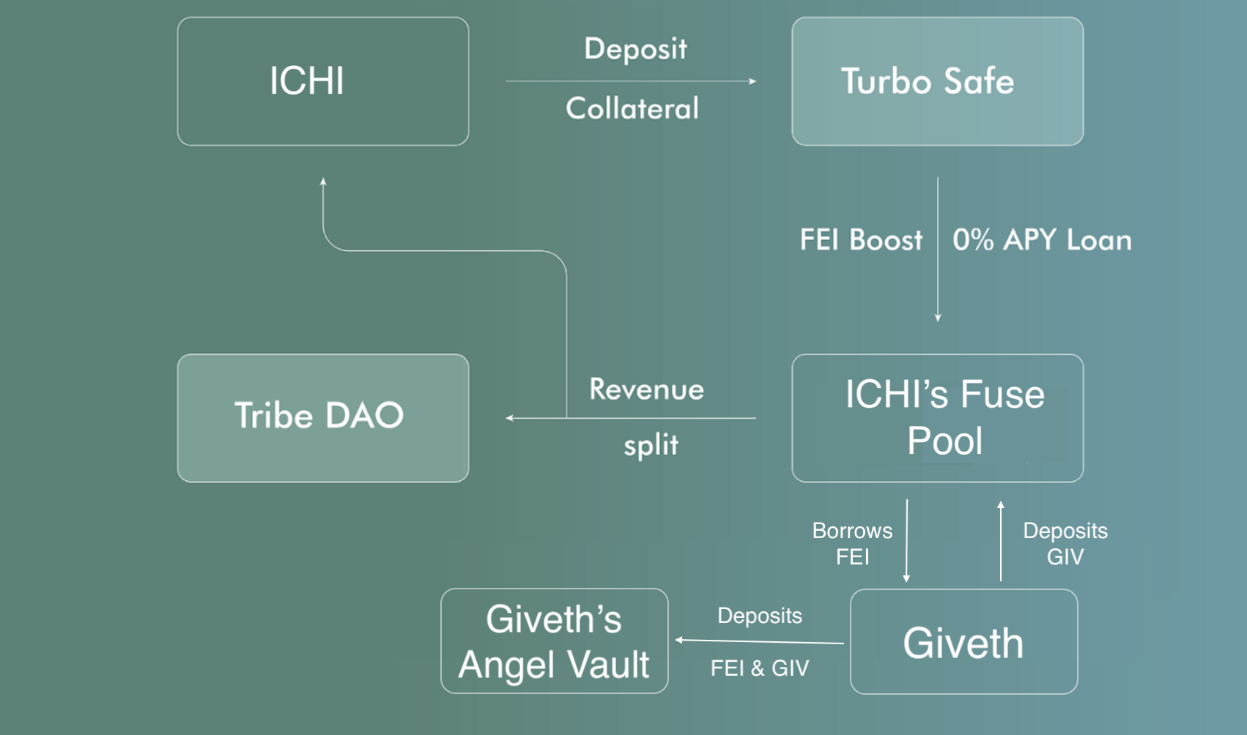

Shapeshift success story with the pool - they borrowed FEI against their governance tokens.

Liquidity mining

Rari Capital Fuse pool > link

Tribe Turbo > <https://medium.com/fei-protocol/the-tribe-dao-strongly-believes-that-a-healthy-and-thriving-defi-ecosystem-needs-a-robust-platform-b1faea700dfa>

—-------